V-400U
5-Axis Vertical Machining Center
Technical Specification
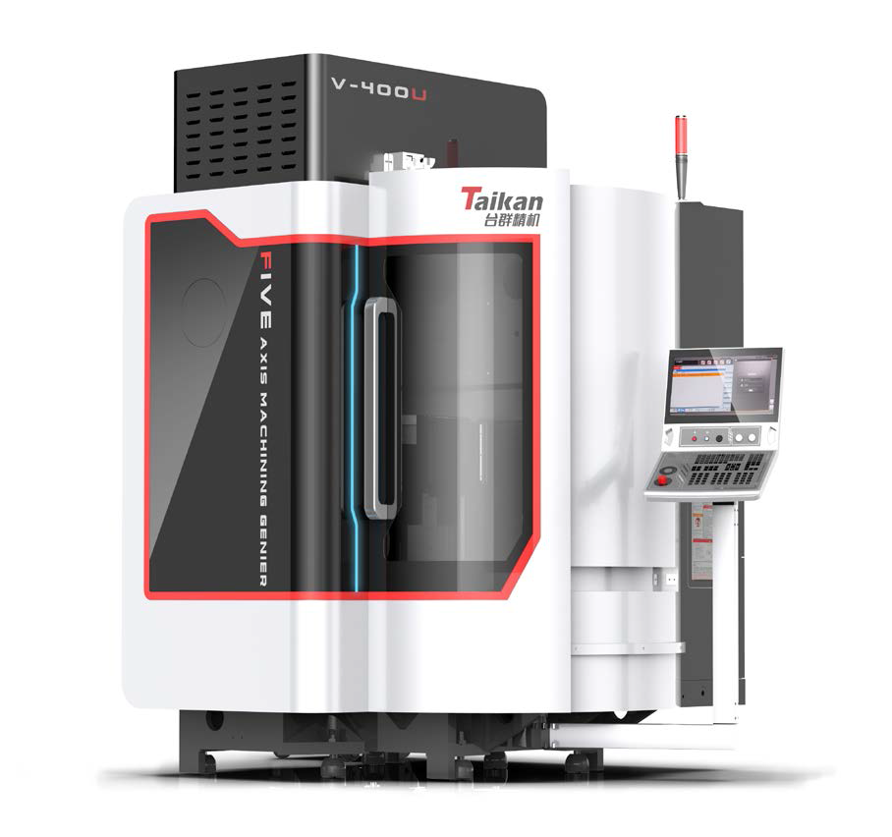

一、Equipment technical description、parameters and configuration
1、Technical description of equipment
V-400U is a vertical machining center with simultaneous 5-axis CNC machining. It can machining metals and non-metals of various materials. It is a 5-axis vertical machining center with high precision, high speed and high rigidity, widely used in the processing of complex parts such as impeller, aviation, auto parts, mold processing, medical equipment and so on.
- The main structure of the machine adopts a high-rigidity portal O-type structure, the distance from the spindle to the beam is short, with reasonable BC axis turntable structure design layout, and the main body is made of high-quality gray cast iron material, which has the characteristics of small overall stress deformation and strong vibration resistance；
- Combined with modern finite element analysis software to continuously optimize and improve the rigidity of the main structure of the machine to achieve the optimal design；
- Equipped with roller guide rails (INA/THK) to improve the rigidity of the transmission; at the same time, the lead screw is designed as NSK high-speed lead screw (with cooling) to ensure better transmission accuracy and stability；
- Self-designed high-rigidity turntable body structure, driven by torque motor, matched with high-resolution circular grating encoder, and the turntable body is designed with reasonable cooling channels to ensure the transmission accuracy and stability of the turntable；
- Equipped with HSK E50 high-speed motorized spindle, the maximum speed can reach 24000rpm/min, ensuring high surface machining quality of parts；
- Equipped with 24T umbrella-shaped tool magazine to meet the multi-tool requirements for complex parts processing；
- The control system applies Siemens SINUMERIK ONE five-axis high-precision control system, Siemens high-precision motor and drive, and linear scale to achieve closed-loop control, effectively ensuring the stability of the overall control accuracy of the machine;
- The operation panel integrates some self-developed functions, including secondary development operation interface, tool magazine management, automatic tool setting, temperature control module, etc., to improve the convenience of operation;
- Combined with industrial design elements and human-computer interaction considerations, the appearance design of the whole machine is neat and beautiful, and the reasonable operation position layout enhances the human-computer interaction experience；
- The standard high-precision laser tool setter can meet the accurate measurement of key parameters such as tool length, diameter and contour of different tool types, so as to ensure the high precision requirements of parts processing。
- Working conditions
- Three-phase AC power supply: 380V±5%; 50Hz±1Hz；
- External power cord: 8mm² (10m and below)/10mm² (10m above)；
- Ambient temperature: The ambient temperature should be kept at 17~25°C (22~24°C constant temperature workshop is recommended), if the precision of the processed parts is not high, it can be relaxed to 5~40°C；
- Relative humidity: ≤80%；
- Keep away from light sources, vibration sources and heat sources, and away from high-frequency generators, discharge motors, electric welding machines, etc., to avoid electrical interference and cause failure of the machine tool NC system.
- Vibration: below 0.2G；
- Foundation requirements: bearing capacity above 50KN/m²；

2、Parameter and configuration
2.1、Basic parameter
Items |  | Unit | Parameter | Remark
Processing | X-axis travel | mm | 700
Processing | Y-axis travel | mm | 450
Processing | Z axis travel | mm | 400
Processing | B axis travel | ° | +30°~ -120°
Processing | C axis travel | ° | 360°continuous rotation
Processing | Distance from spindle nose to table | mm | 100-500
Workpiece size | Maximum allowable workpiece size (diameter*height) | mm | Φ420*420
Work table | Work table size | mm | Φ420
Work table | Max loading | kg | 150
Work table | T-slot (number-width * spacing) | mm | 8-14H9（Evenly distributed）
Spindle | Motor power | kW | 16
Spindle | Motor torque (S1/S6) | Nm | 28/34
Spindle | Rotational speed range | r/min | 0～24000 | long-term use speed is 80% of the maximum spindle speed
Spindle | Spindle diameter | mm | Φ150
Spindle | Spindle taper | / | HSK E50
Guide Rail | X-axis | mm | 2-35 Rollers
Guide Rail | Y-axis | mm | 2-35 Rollers
Guide Rail | Z-axis | mm | 2-35 Rollers
Drive | X/Y/Z axis screw (diameter * lead) | mm | X/Y/Z:32/10
Drive | X/Y/Z/B/C Motor power | kw | 4.5/4.5/4.5/4.46/2.66
Speed | X/Y/Z axis fast moving speed | mm/min | 24000
Speed | X/Y/Z axis cutting feed speed | mm/min | 0-24000
Speed | B/C axis fast moving speed | r/min | 50
Speed | B/C axis cutting feed speed | r/min | 0-50
Machine accuracy | Positioning（X/Y/Z） | mm | 0.005
Machine accuracy | Repeatability（X/Y/Z） | mm | 0.003
Machine accuracy | Positioning（B/C） | sec | 8/8
Machine accuracy | Repeatability（B/C） | sec | 5/5
Tool Storage | Tool capacity | T | 24
Tool Storage | Tool weight | kg | 2
Tool Storage | Tool length | mm | 200
Tool Storage | Max. diameter(full/adjacent ) | mm | Φ50/φ100
Others | Control system |  | Siemens  SINUMERIK ONE
Others | Air pressure | MPa | 0.6∼0.8
Others | Total electrical capacity | kW | 42
Others | Cooling tank capacity | L | 200
Others | Machine dimensions (L*W*H) | mm | 3400*2400*3050
Others | Machine weight（approx.） | kg | 7000
#:No further notice will be given for the change of machine tool dimensions due to configuration

2.2、Standard configuration
No. | Description | Unit | Remark
1 | Siemens  SINUMERIK ONE system | 1
2 | THK/INA three-axis roller guide | 1
3 | NSK three-axis high-speed screw (with cooling) | 1
4 | DD direct drive four or five axis turntable | 1
5 | HSK E50 high-speed electric spindle | 1
6 | Intelligent operation panel | 1
7 | 24T Umbrella tool | 1
8 | Centralized automatic grease lubrication system | 1
9 | Spindle and screw cooling system | 1 | Inverter water cooler
10 | Workpiece cooling system | 1
11 | SMC/CKD air system | 1
12 | Sheet metal full protective cover | 1
13 | fuel tank assembly | 1
14 | Explosion Proof Work Lights | 1
15 | Three-color warning light | 1
16 | security door lock | 1
17 | Three-axis HEIDENHAIN linear encoder | 1
18 | Circular grating (for 4-5 axis turntable) | 1
19 | Laser tool setter | 1
20 | Power failure fallback protection device | 1
21 | Electric control cabinet air conditioner | 1
22 | Rear flush inside the machine | 1
23 | Toolbox and Tools | 1
24 | A set of machine tool maintenance and operating program manuals (electronic version) | 1

2.3、Accessories list
No. | Description | Specification | Quantity | No. | Remark
1 | Toolbox | Plastic /360*160*180/13" | PCS | 1
2 | Screwdriver | SATA/slotted/6*150MM | PCS | 1
3 | Screwdriver | SATA/slotted/6*150MM | PCS | 1
4 | 9-piece vanadium steel extension set | SATA/1.5mm-10mm 09107A | SET | 1
5 | Tool shank | HSK-50E | PCS | 1
6 | Nozzle | ER20-φ3.4.6.8.10 | SET | 1
7 | Lock tool seat | HSK-E40 | PCS | 1
8 | Bayonet socket wrench | ER20-MS | PCS | 1
9 | CF Card | 1G | PCS | 1
10 | Operating Instructions | Siemens System Manual | PCS | 1
11 | Carton | Printing "Taikan"/36*45*38CM | PCS | 1

二、Main component brand
No. | Description | Quantity | Brand | Remark
1 | screw bearing | 6 | Germany FAG/Japan NSK
2 | Ball screw | 3 | Japan NSK
3 | Roller guide rail | 3 | Japan THK/German INA
4 | Spindle | 1 | Taikan
5 | Tool magazine | 1 | Taikan
6 | Main pneumatic components | 1 | SMC/CKD
7 | torque motor | 2 | Siemens, Germany
8 | Three-axis servo motor | 3 | Siemens, Germany
9 | CNC system | 1 | Siemens, Germany
10 | Tool magazine drive servo motor | 1 | Siemens, Germany
11 | Lubrication device | 1 | Proton / Streaming
12 | Three-axis linear encoder | 1 | Heidenhain
13 | Laser tool setter | 1 | Renishaw/Polon
On the premise of ensuring the quality of the machine tool, in order to ensure the delivery time, the manufacturers of purchased parts of the same grade can be adjusted after consultation.

